Handedness
Name: Click or tap here to enter text.
Introduction
The ability to use both hands equally is increasingly becoming more important in many sports. Scientists develop tests using the scientific method to determine how well an athlete can use both hands. In this activity you will test the accuracy of each of your hands and then evaluate the fairness of the test that has been developed.
- Name two sports where it is an advantage to use both hands equally.
Click or tap here to enter text.

Aim
To determine how handedness affects accuracy.
Hypothesis
My Choose an item. hand will be more accurate as it is my Choose an item. preferred hand.
Materials and method
- Cup (such as a coffee cup/mug)
- Measuring tape
- Cone (or something similar such as a bottle)
- 5 x scrunched up small pieces of waste paper (make sure all are the same size)

- Place the cup on the ground in the centre of a large space (can be outdoors if not windy).
- Use the tape to measure a distance of two metres away from the cup and place your cone (or bottle) at this point.
- Sit down behind the cone and try to get the pieces of paper in the cup by throwing them individually with your right hand.
- Measure the distance that each piece of paper landed from the cup and enter it in the results table (if it lands in the cup then this should be measured as 0 cm).
- Repeat the experiment but this time use your left hand.
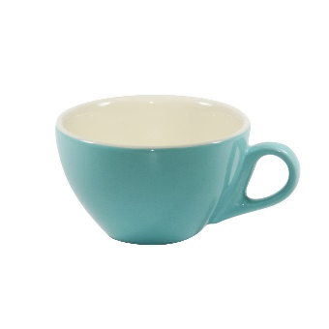
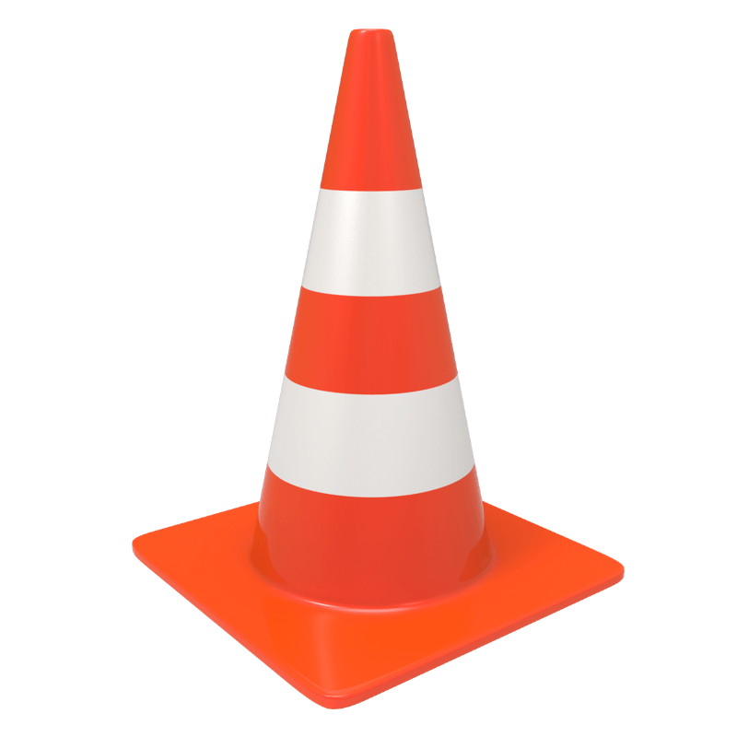
© BioLAB: The Victorian BioScience Education Centre
2 m
Results
- Calculate the mean (average) for the distance the paper lands from the cup after you have completed the experiment.
Distance paper lands from cup (cm).
Throw | Right hand | Left hand
1 | Valuecm | Valuecm
2 | Valuecm | Valuecm
3 | Valuecm | Valuecm
4 | Valuecm | Valuecm
5 | Valuecm | Valuecm
Mean | Valuecm | Valuecm

- Use excel to create a column graph that compares the mean results. Instructions on how to create a column graph on excel can be found here: https://www.youtube.com/watch?v=dwaoJYSiTZ0
Discussion
- Describe the result trends in a sentence (ensure you mention both mean results in the sentence).
Click or tap here to enter text.

- Did the results match the hypothesis? Provide a reason as to why these results were obtained.
Click or tap here to enter text.

- Compare your result to two other class members. Explain why any similarities or differences exist.
Click or tap here to enter text.

- A fair test using the scientific method always has clear independent (experimental), dependent (observed) and controlled variables. Identify the variables in the experiment by completing the table below. The following clip may help you: https://www.youtube.com/watch?v=iaewZmc4TYQ
Variable | In handedness experiment
Independent | Choose an item.
Dependent | Choose an item.
Controlled | Choose an item.
© BioLAB: The Victorian BioScience Education Centre
- Did any unexpected events occur during your experiment that would mean that the test was not a fair test? If you were to repeat the experiment what steps could you take to reduce the chance of these unexpected events occurring?
Click or tap here to enter text.

- Suggest a training method you could adopt if you wanted to improve the use of your non-preferred hand?
Click or tap here to enter text.

Conclusion
- Write one clear paragraph that summarises your findings. The conclusion should relate directly to the question answered, your hypothesis and the results that you obtained (make sure you quote your results).
Good sentence starters are “The question that was investigated…”, It was predicted that….,“The results were …” and “The results indicated that…”.
Click or tap here to enter text.

Further task
Design your own test for handedness using only the equipment you have available to you at home. Ask your friends to complete and evaluate your test.
© BioLAB: The Victorian BioScience Education Centre

