Marathon Glory!

Student Name:

Background
Marathon athletes have never before been equipped with such impressive works of engineering and technology on their feet. The major shoe companies are constantly striving to seek the edge for their athletes, to help compliment their training and nutrition.

Task
Use the information provided below to calculate the athletes percentage difference or ‘improvement’ in the marathon over the last few years.

Data
Jared Ward  USA |  | Mosinet Geremew  ETHIOPIA |  | Eliud Kipchoge  KENYA
Wears Saucony Type A |  | Wears Nike ZoomX Vaporfly Next % |  | Wears Nike ZoomX Alphafly Next %
Personal Best Times |  | Personal Best Times |  | Personal Best Times
2015 | 2:12:55 | 2016 | 2:04:00 | 2013 | 2:05:30
2016 | 2:13:00 | 2017 | 2:06:12 | 2016 | 2:08:44
2016 | 2:11:30 | 2018 | 2:05:24 | 2018 | 2:01:39*
2019 | 2:10:45 | 2019 | 2:02:55 | 2019 | 1:59:40**
* Fastest marathon time ever recorded in a sanctioned event. Current worlds best time.
** Fastest marathon time ever, however it was an organised event to try and break the 2-hour mark so Kipchoge was allowed pacers, wind breaks and ran laps on a fat formula one circuit. It therefore does not stand as the world’s best time, however proves it is humanly possible to run a marathon in under 2-hours.

© BioLAB: The Victorian BioScience Education Centre

Example Calculations
To calculate the percentage difference or ‘improvement’ of an athletes marathon times you need to use the following formula where A is the athlete’s slowest marathon time (min) and B is the athlete’s fastest marathon time (min).

$$Percentage difference= \frac{A-B}{\left(\frac{A+B}{2}\right)} ×100$$

A is the athlete’s slowest marathon time (min)
B is the athlete’s fastest marathon time (min)

Example Marathon Times

Slowest marathon time = 2:23:10
Fastest marathon time = 2:16:56

Step 1. Convert the marathon time from hours:minutes:seconds format (as shown above) to only minutes (rounding to the nearest minute).

- Slowest marathon time - 2:23:10 = 143 minutes
- Fastest marathon time - 2:16:56 = 137 minutes

Step 2. Substitute marathon times (minutes) into the formula.

$$Percentage difference= \frac{143-137}{\left(\frac{143+137}{2}\right)} ×100$$

Step 3. Complete calculations within the bracket; addition first then division.
- 143 + 137 = 280
- 280 ÷ 2 = 140
$$Percentage difference= \frac{143-137}{\left(\frac{280}{2}\right)} ×100$$

$$Percentage difference= \frac{143-137}{140} ×100$$

Step 4. Complete subtraction.
- 143 - 137 = 6
$$Percentage difference= \frac{6}{140} ×100$$

Step 5. Complete division (round to 4th decimal place).
- 6 ÷ 140 = 0.0429

$$Percentage difference= 0.0429 ×100$$

Step 6. Complete multiplication (round to 2nd decimal place).
- 0.0429 × 100 = 4.29

$$Percentage difference= 4.29$$

Solution. This athlete’s marathon time improved by 4.29%.
© BioLAB: The Victorian BioScience Education Centre

Calculating Improvement
- Calculate Jared Ward’s improvement between his slowest and fastest marathon times using the percentage difference formula. Take a photo of your calculations (ensure you are writing out each step) and insert the image below.

NOTE: Your working out should look similar to this.

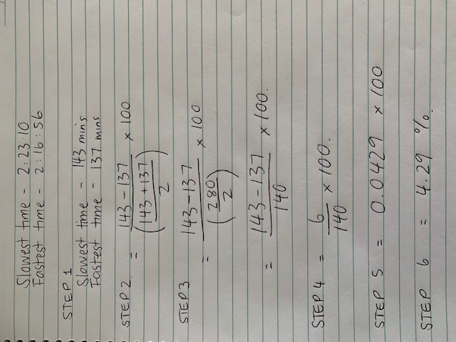

Solution. Jared Ward’s marathon time improved by Click or tap here to enter text.%.
© BioLAB: The Victorian BioScience Education Centre
- Calculate Mosinet Geremew’s improvement between his slowest and fastest marathon times using the percentage difference formula. Take a photo of your calculations (ensure you are writing out each step) and insert the image below.

Solution. Mosinet Geremew’s marathon time improved by Click or tap here to enter text.%.

- Calculate Eliud Kipchoge’s improvement between his slowest and fastest marathon times using the percentage difference formula. Take a photo of your calculations (ensure you are writing out each step) and insert the image below.

Solution. Eliud Kipchoge’s marathon time improved by Click or tap here to enter text.%.

© BioLAB: The Victorian BioScience Education Centre

Conclusion
There are many factors that impact an athlete’s performance and improvement, especially in marathon running. Look back at the athlete profiles on page one and the calculations you completed to help you answer the following questions.

- Which shoe was associated with the largest percentage change?

Choose an item.

- Research the Nike ZoomX Alphafly Next% by clicking on the link below and identify 4 factors that make it such a unique running shoe.
https://www.wired.co.uk/article/nike-alphafly-eliud-kipchoge

Click or tap here to enter text.

- Why has the World Athletics made new specification limits on shoes based upon the Nike ZoomX Alphafly Next%?

Click or tap here to enter text.

- List some factors other than the shoe that could have contributed to the athletes’ improvement?

Click or tap here to enter text.

Extension
The Nike ZoomX Alphafly Next% has had a major impact on World Athletics, with the governing body changing rules to essentially ban the shoe.

Research another example where the engineering of shoe wear, clothing or equipment has had a detrimental impact on the sport.
© BioLAB: The Victorian BioScience Education Centre

