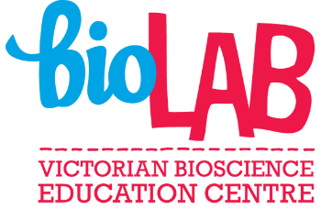
Coded for Success Online
Student work plan
Learning intention:
To understand the genetic screening process.
Success criteria:
- Demonstrate a clear understanding of the terms genotype, phenotype, gene, allele, homozygous and heterozygous.
- Explain how the differences in DNA sequence within a gene results in different traits.
- Identify the role of gel electrophoresis in organising and predicting DNA fragment size.
- Calculate using a probability table, the genotypes and phenotypes of different genetic crosses.
- Express phenotype ratio as a percentage and as a fraction.
Instructions for students
Instructions | Time required | Links
Introduction Task  - Download the introduction task, save to your device and then select view and select edit document.  - Complete the introduction task electronically. Use any resources that you have available.  - Submit the task to your teacher to provide feedback | Allow up to 1 hour | Introduction task
Main Task.  - Download the digital workbook, save to your device and then select view and select edit document.  - Watch the video provided (recommend with headphones).  - Complete question 1.  - Download the results page and complete task. Use these results to complete the results section of your digital workbook.  - Complete the remainder of your workbook. Use the genetic cross example provided to assist you when completing question 6.  - Submit your workbook to your teacher for feedback. | Allow up to 1.5 hours | Digital workbook  Scientific method video  Gel electrophoresis results  Genetic cross example
Further Task  - Download the further task and print a hard copy.  - Complete the further task, scan and submit to your teacher for feedback. | Allow up to 1 hour | Further task

