Name: Click or tap here to enter text.
Cardiac Adaptations to Exercise
Overview
Over the course of a six month training program an endurance athlete had three cardiac measurements (heart rate, stroke volume and cardiac output) taken periodically to determine the effect training has on the heart. Complete the following activity to determine the effect training has on the heart and how maths is used by exercise physiologists to track the progress of an athlete.
Definitions
- Complete the following table to define the cardiac measurements that were taken during the training program (you may use the internet to help you).
Cardiac value | Definition | Measurement unit
Heart rate | Choose an item. | Choose an item.
Stroke volume | Choose an item. | Choose an item.
Cardiac output | Choose an item. | Choose an item.

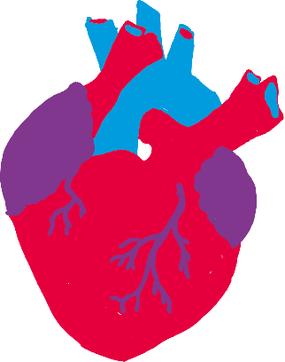
Calculations
The following equation is used to calculate cardiac output:
Cardiac output = Heart rate x stroke Volume
- Rearrange the equation to make:
  - heart rate the subject of the equation:
Heart rate = Click or tap here to enter text.
  - stroke volume the subject of the equation:
Stroke volume = Click or tap here to enter text.

Resting values
The table below displays how training effects the cardiac values at rest.
- Use the cardiac equations above to complete the values in the table below:
Month of training | Heart rate | Stroke volume | Cardiac output | Cardiac output
0 | 80 bpm | 60 ml | Click or tap here to enter text. ml/min | 4.800 L/min
2 | 61 bpm | 85 ml | Click or tap here to enter text. ml/min | Click or tap here to enter text. L/min
4 | 55 bpm | Click or tap here to enter text. ml | 5665 ml/min | 5.665 L/min
6 | Click or tap here to enter text. bpm | 110 ml | 5610 ml/min | 5.610 L/min

- Use excel to create 3 line graphs to display how training effects your heart function at rest.
  - Graph One – Heart Rate (X axis – month of training, Y axis – heart rate)
  - Graph Two – Stroke Volume (X axis – month of training, Y axis – stroke volume)
  - Graph Three – Cardiac Output (X axis – month of training, Y axis – cardiac output)
- Describe the trend of the graph for each of the cardiac values.
Graph | Trend
Heart rate | Click or tap here to enter text.
Stroke volume | Click or tap here to enter text.
Cardiac output | Click or tap here to enter text.

- Explain why you think training has this effect on an athlete’s resting heart rate.
Click or tap here to enter text.

Maximum effort values
The table below displays how training effects the cardiac values at maximum effort (exercising as hard as you can for 45 seconds).
- Use the cardiac equations above to complete the values in the table below:
Month | Heart rate | Stroke volume | Cardiac output | Cardiac output
0 | 195 bpm | 120 ml | 23400 ml/min | Click or tap here to enter text. L/min
2 | 196 bpm | 166 ml | Click or tap here to enter text. ml/min | Click or tap here to enter text. L/min
4 | 194 bpm | Click or tap here to enter text. ml | 39382 ml/min | 39.382 L/min
6 | Click or tap here to enter text. bpm | 220 ml | 42900 ml/min | 42.900 L/min

- Use excel to create 3 line graphs to display how training effects your heart function at maximum effort.
  - Graph One – Heart Rate (X axis – month of training, Y axis – heart rate)
  - Graph Two – Stroke Volume (X axis – month of training, Y axis – stroke volume)
  - Graph Three – Cardiac Output (X axis – month of training, Y axis – cardiac output)
- Describe the trend of the graph for each of the cardiac values.
Graph | Trend
Heart rate | Click or tap here to enter text.
Stroke volume | Click or tap here to enter text.
Cardiac output | Click or tap here to enter text.

- Explain why you think that training has this effect on an athlete’s stoke volume.
Click or tap here to enter text.

- If we were to measure the athlete’s oxygen consumption per minute at maximum effort would the value be greatest at zero or six months? Explain how you were able to come to this conclusion.
Click or tap here to enter text.

