Click or tap here to enter text.
Deep Dive Data
Student Name:
Introduction
Scatter plots allow you to demonstrate the relationship or correlation between two variables. They are represented on a Cartesian Plane with the data plotted on the graph using coordinates (x, y).
Big data sets can be visualised on scatter plots and a ‘line of best fit’ can then be used to make predictions.
Your challenge today is to use data collected from the 2016 Rio Olympic Games to explore how correlations can be used to improve an athlete’s performance.
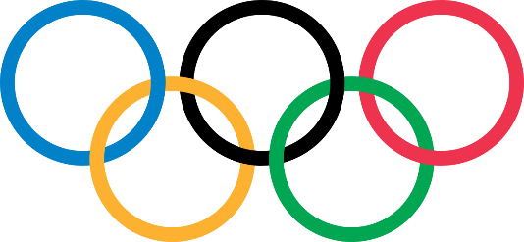

Data
Click on the link below to access the excel document you will need to complete this task.
Deep Dive Data
The following question will require you to think about different strategies you could use to solve the problems.
For question one, use excel to create a scatter plot. Then take a screenshot and paste that image into the picture box.
Data Analysis
- Use Excel to complete a scatter plot of the ‘Deep Dive Data’.
- Which country were the athletes from?
Click or tap here to enter text.
- What is the unit of measurement for height?
Click or tap here to enter text.
- What two variables does one dot on a scatter plot represent?
Click or tap here to enter text.
- What is the range of the height and weight of the athletes in the data set?
Height Range | Click or tap here to enter text. | Weight Range | Click or tap here to enter text.
- If your height is outside the range of this data set could you still be an Olympic swimmer?
Click or tap here to enter text.
- Identify the height and weight for a swimmer that most often appear in the data set? Round to nearest whole number.
Height | Click or tap here to enter text. | Weight | Click or tap here to enter text.
- What is the height of the shortest athlete? Are they also the lightest in weight?
Click or tap here to enter text.
- Finish the sentence to describe the correlation between a swimmers height and weight:
As a swimmers height increases Click or tap here to enter text.
- How could this data be used to improve an athlete’s performance?
Click or tap here to enter text.
- If an Olympic swimmer is 190cm tall, what would you predict their weight to be? Hint: You need to add a line of best first to your scatter plot to answer this question.
Click or tap here to enter text.

