Survival of the Fittest
Click to enter name
Name:
- Find definitions and examples to complete the vocabulary table below.
Term | Definition | Example
Adaptation | A physical or behavioural trait that improves an organism’s ability to survive and reproduce in its environment. Adaptations are the result of evolution. | Click to enter text.
Evolution | Click to enter text. | Click to enter text.
Natural Selection | Click to enter text. | Click to enter text.
Biomimicry | Click to enter text. | Click to enter text.
- Complete the table by stating which of the pictured organisms inspired the product design and outlining the feature of the organism that is being ‘mimicked’.
Which organism do you think inspired the design?
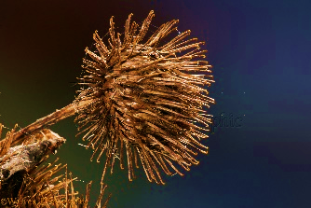
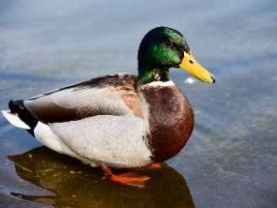
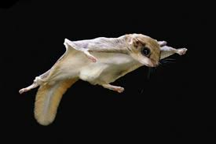

Duck
Flying Squirrel
Burdock plant seed (burr)
Product | Inspired by | Mimicked Adaptation
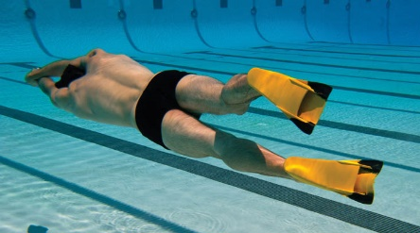  Swimming Fins | Choose an item. | Click to enter text.
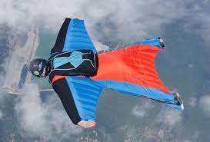  Wingsuit | Choose an item. | Click to enter text.
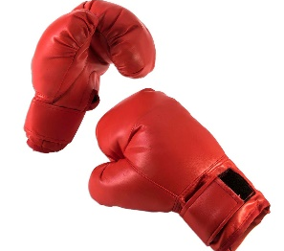  Velcro | Choose an item. | Click to enter text.
Biomimetic Design
In the field of biomimetic design, biomimicry is used to enhance sports equipment design in order to improve participant safety and comfort or to enhance performance. Some examples include running shoes for greater grip designed on cheetah claws and utilising the design of a pine cone to develop fabrics that allow better ventilation and sweat evaporation.

You will need to read the information about “Biomimetics in Sport” at this web link to complete the following questions. If you are unable to access the website all of the information can be found in accompianing “Biometrics in Sport Web Article” word document. You may also like to watch this short you tube video on biomimicry and this video about gecko grip.

- Read about LZR speedo swimsuits and fill in the gaps to complete the biomimicry design brief below.
Project name: LZR speedo swimsuits | Target sport(s): Swimming
Biomimicry summary:
Speedo LZR designed swimsuits to improve performance by enter text. The swimsuit fabric incorporated the same structures as seen in enter text. Shark skin contains tiny scale like structures called enter text which reduce both enter text and turbulence, allowing sharks to move through the water efficiently.
Design diagram:
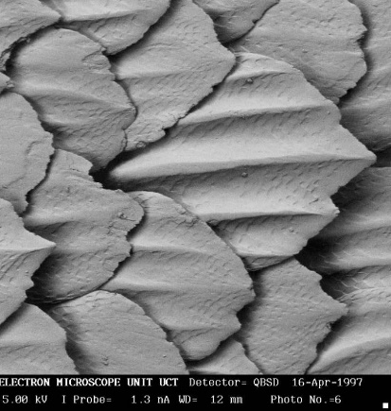
Denticle pattern of shark skin incorporated into panels of swimsuit
to
reduce drag.

- Using the previous design brief as a guide, complete a design brief for an existing sports biomimetic design of your choice. You can use the information provided or do your own research.
Click on the picture box to insert a picture.
Project name: enter text. | Target sport(s): enter text.
Biomimicry summary: enter text.
Design diagram:
enter text
incorporated into
enter text
to
enter text
- Come up with other possible applications of the adaptations used in the biomimetic designs above.
Adaptation | Target Sport | Biomimetic Sport Design Idea
Choose an item.  If other specify:  enter text. | enter text. | enter text.
Choose an item.  If other specify:  enter text. | enter text. | enter text.
Is it fair?
The Speedo LZR Elite swimsuit was marketed as “the fastest swimming suit in the world” and was launched at the 2008 Olympic Games.
- Some, but not all swimmers competed in the suit. Outline some reasons why not all swimmers would have used the swimsuit, even though it was “the fastest swimsuit in the world”.

Click or tap here to enter text.
- Do you think it’s fair that some swimmers were able to utilise biomimetic design to gain a performance advantage? Explain why/why not.
Click or tap here to enter text.

